AI ASSISTENT CODING 13.4

P.Deepak
2303A52179
Batch - 42

Task 1: Refactoring Data Transformation
Logic
Scenario
You are maintaining a data preprocessing script where numerical
transformations are written using verbose loops.
Task Description
• Review the legacy code that computes transformed values using
an explicit loop.
• Use an AI tool to suggest a more Pythonic refactoring approach.
• Refactor the code using list comprehensions or helper functions
while preserving the output.

Code:
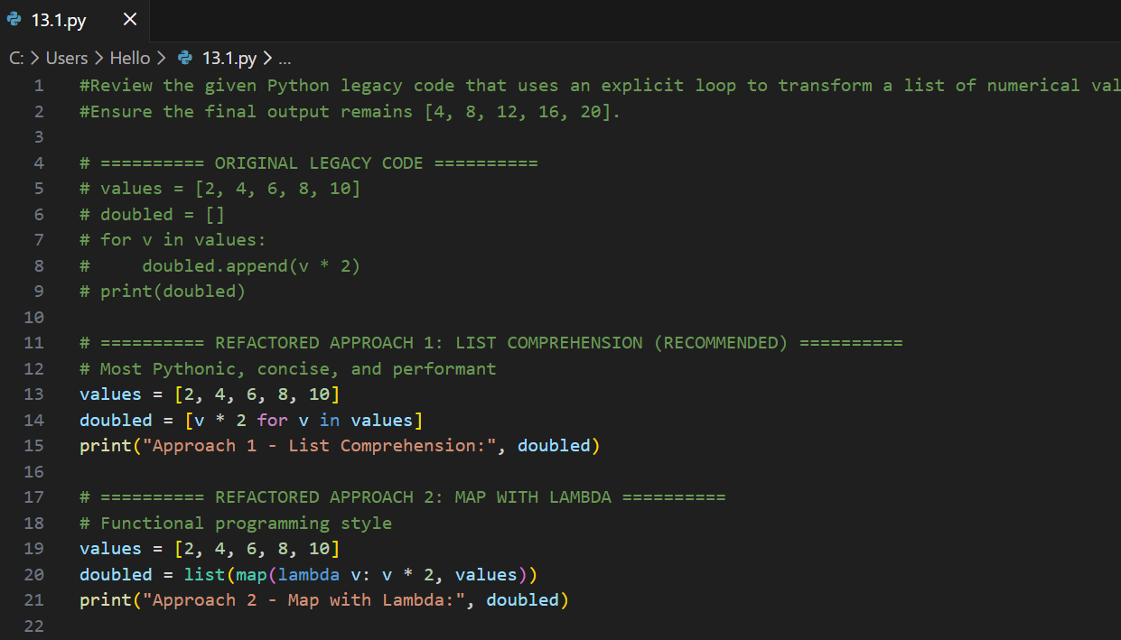
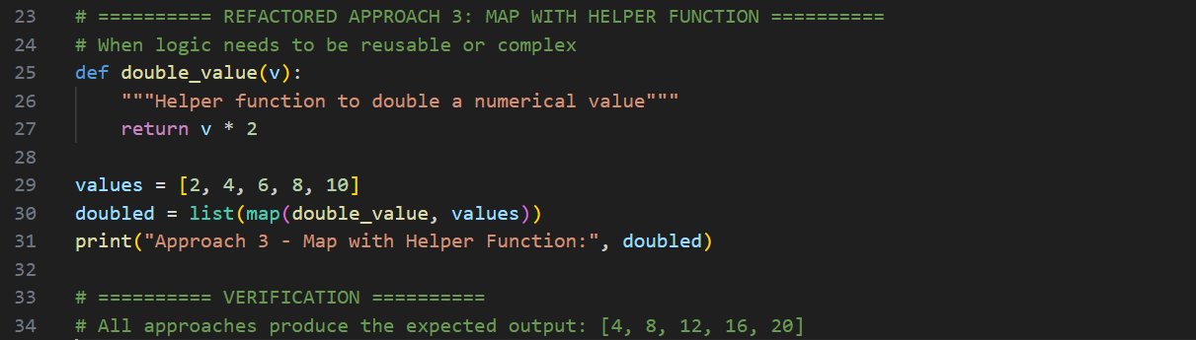

Output:
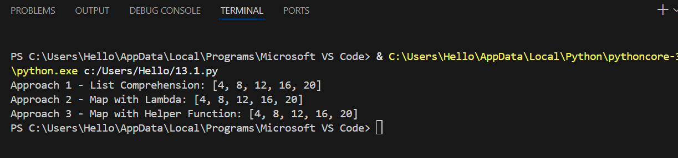

Justification:
The original code uses a verbose loop to perform a simple numerical transformation, which reduces readability. Refactoring it using a list comprehension makes the code more concise, Pythonic, and easier to understand while producing the same output. This approach also reduces the number of lines and improves maintainability.

Task 2: Improving Text Processing Code
Readability
Scenario
You are working on a log message generator that builds messages word
by word.
Task Description
• Analyze the legacy code that constructs a sentence using repeated
string concatenation.
• Ask AI to suggest a more efficient and readable approach.
• Refactor the code accordingly while keeping the final output
Unchanged.

Code:
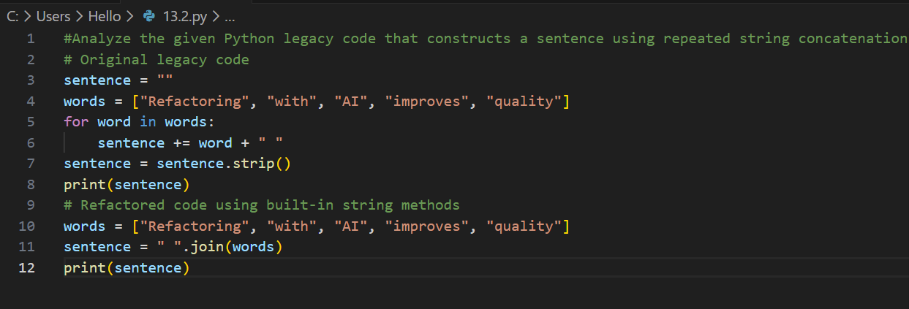
Output:
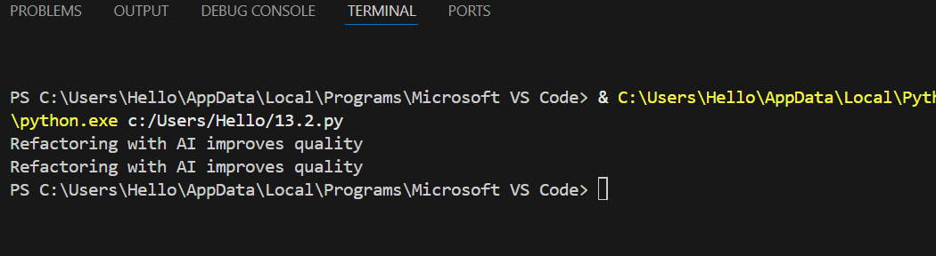

Justification:
The legacy code builds a string using repeated concatenation inside a loop, which is inefficient and harder to read. Using Python’s built-in string joining methods results in cleaner, faster, and more readable code. The refactored solution preserves the exact output while following Python best practices.

Task 3: Safer Access to Configuration Data
Scenario
You are maintaining a configuration loader where dictionary keys may
or may not exist depending on deployment settings.
Task Description
• Review the legacy code that manually checks for dictionary keys.
• Use AI suggestions to refactor the code using safer dictionary
access methods.
• Ensure the behavior remains the same for missing keys.

Code:
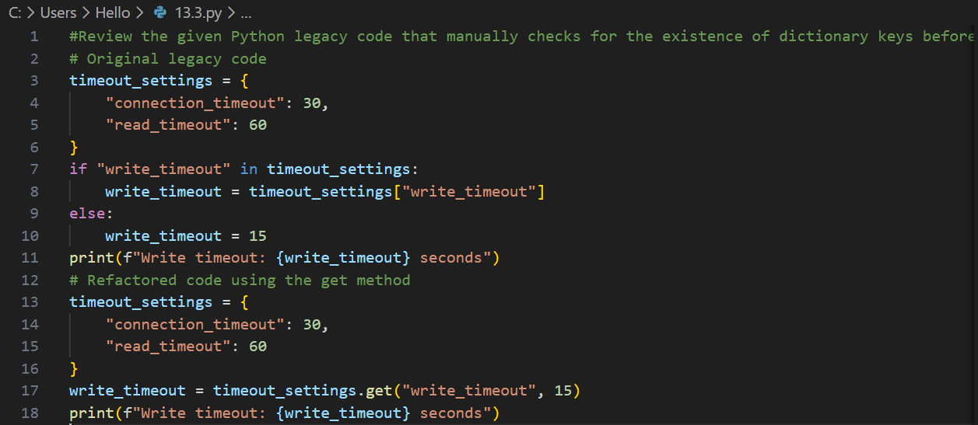

Output:
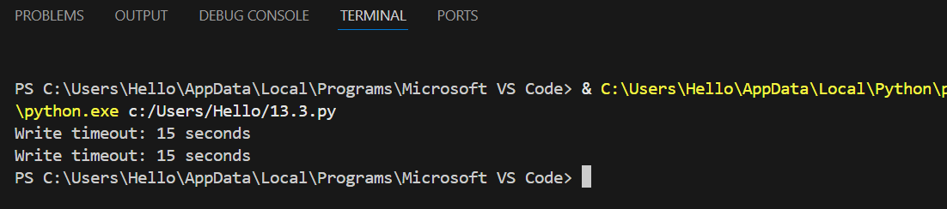

Justification:
The original code explicitly checks for the presence of a key before accessing it, which increases verbosity. Refactoring using safer dictionary access methods like get() simplifies the code, improves readability, and avoids potential key access errors while preserving the same behavior for missing configuration values.

Task 4: Refactoring Conditional Logic for
Scalability
Scenario
You are enhancing a utility module that performs different operations
based on user input.
Task Description
• Examine the multiple if–elif conditions used to determine
operations.
• Ask AI to suggest a cleaner, scalable alternative.
• Refactor the logic using mapping techniques while preserving
Functionality.
Code:
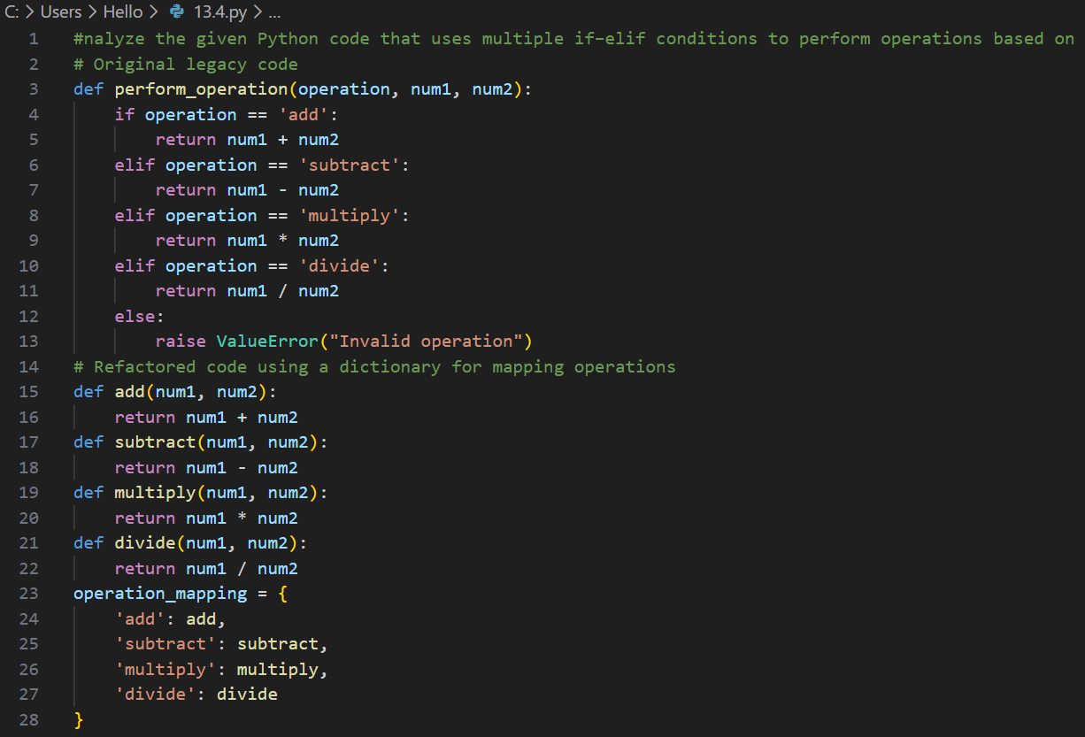
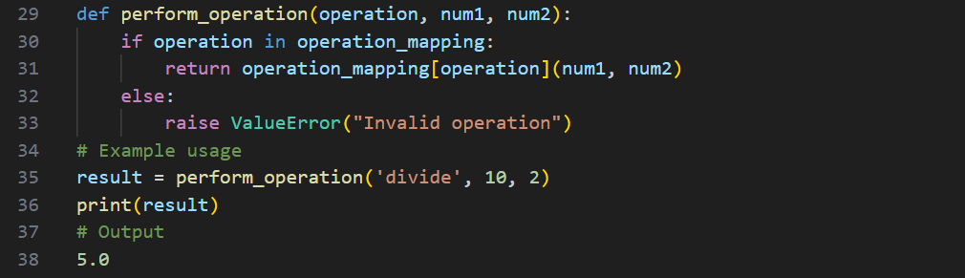

Output:
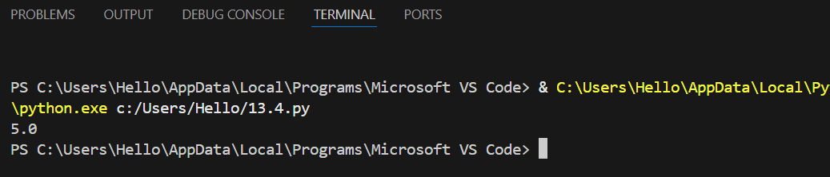

Justification:
The original implementation relies on multiple if–elif conditions, which becomes harder to maintain as the number of operations grows. Using a mapping-based approach improves scalability, reduces code complexity, and makes it easier to add new operations while preserving the same functionality and output.
Task 5: Simplifying Search Logic in
Collections
Scenario
You are reviewing legacy inventory-check code that uses manual loops
to find elements.
Task Description
• Identify the explicit loop used for searching an item.
• Use AI assistance to refactor the logic into a more concise and
readable form.
• Maintain the same output behavior.

Code:
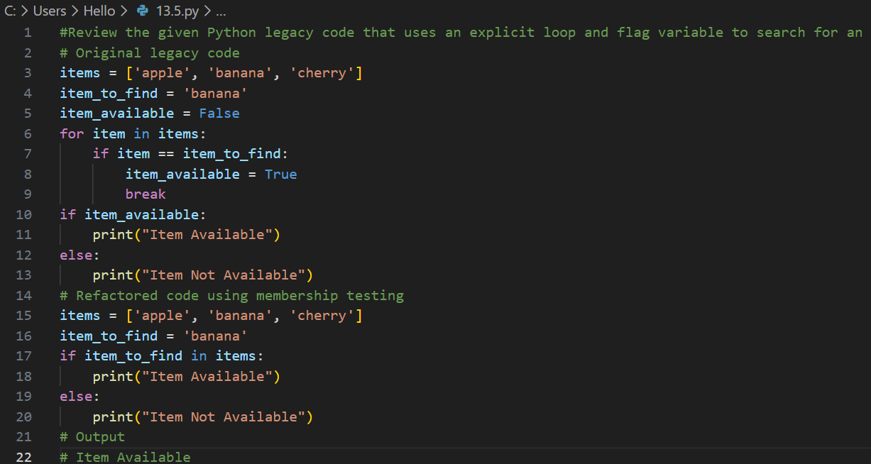

Output:
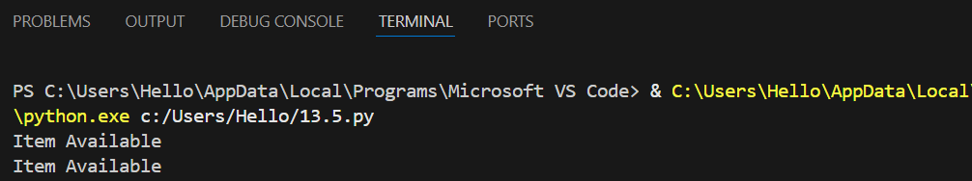

Justification:
The original code uses a manual loop and flag variable to check for item existence, which adds unnecessary complexity. Refactoring with Python’s built-in collection search capabilities improves readability, reduces code length, and preserves the same output behavior.

